Unconditional Branches:

A)

Clock cycle 1 2 3 4 5 6 7 8 🡪 Time

|  |  |  |  |  |
| --- | --- | --- | --- | --- |
| F | D | C |  |  |

I(j): Branch to I(k)

|  |  |  |  |  |
| --- | --- | --- | --- | --- |
| F | D |  |  |  |

I(j+1)

|  |  |  |  |  |
| --- | --- | --- | --- | --- |
| F |  |  |  |  |

I(j+2)

|  |  |  |  |  |
| --- | --- | --- | --- | --- |
| F | D | C | M | W |

I(k)

🡨------🡪

Branch penalty

B)

Clock cycle 1 2 3 4 5 6 7 🡪 Time

|  |  |  |  |  |
| --- | --- | --- | --- | --- |
| F | D |  |  |  |

I(j): Branch to I(k)

|  |  |  |  |  |
| --- | --- | --- | --- | --- |
| F |  |  |  |  |

I(j+1)

|  |  |  |  |  |
| --- | --- | --- | --- | --- |
| F | D | C | M | W |

I(k)

🡨------🡪

Branche penalty

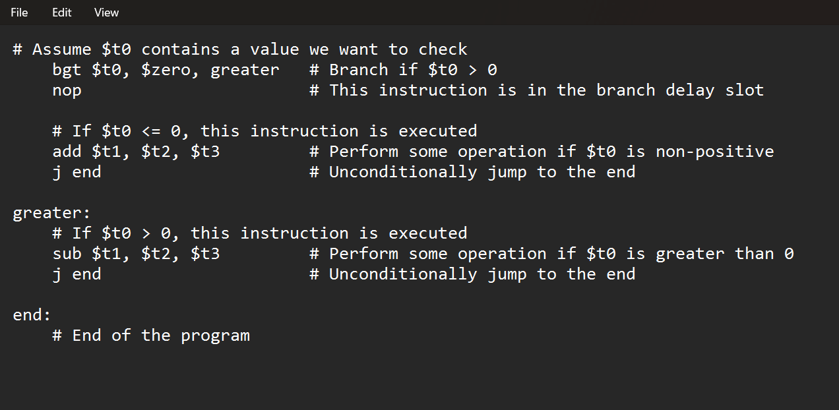

Conditional Branches:

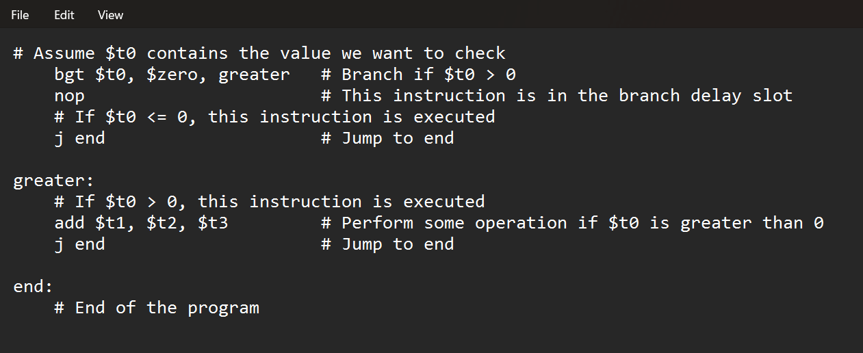

Branch Deloy Slot:

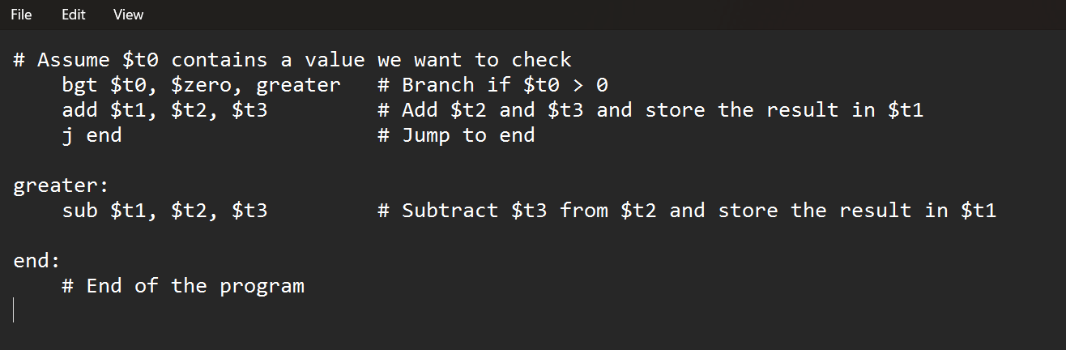

Branch Prediction:

